Title Page:
Type of article: Letter
Title: Both local habitat quality and diversified agricultural landscapes support the restoration of metacommunity cohesion in calcareous grasslands
Short Title: Local & landscape quality to restore interactions.
List of Authors:
Elena Velado-Alonso^{1,2} (corresponding autor): https://orcid.org/0000-0003-4805-2929 // elena.velado@outlook.es / elena.veladoalonso@uni-goettingen.de
Ira Hannappel¹: https://orcid.org/0009-0005-0467-4787 // ira.hannappel@uni-goettingen.de
Felipe Librán-Embid³: https://orcid.org/0000-0003-4898-4494 // felipe.libran-embid@allzool.bio.uni-giessen.de
Elisabeth Prangel⁴: https://orcid.org/0000-0003-0776-5017 // elisabeth.prangel@ut.ee
Jelle Devalez⁴: https://orcid.org/0000-0003-1110-0640. // jelle.devalez@gmail.com
Tanel Vahter⁴: https://orcid.org/0000-0002-4343-5288 // tanel.vahter@ut.ee
Aveliina Helm⁴ : https://orcid.org/0000-0003-2338-4564 // aveliina.helm@ut.ee
Triin Reitalu^{4,5}: https://orcid.org/0000-0002-6555-3066 // triin.reitalu@ut.ee
Gerard Bota⁶, https://orcid.org/0000-0001-9020-7272 // gerard.bota@ctfc.cat
Xabier Cabodevilla^{6,7}: https://orcid.org/0000-0002-5793-7916 // xabier.cabodevilla@ehu.eus
David Giralt⁶: https://orcid.org/0000-0001-9712-1957 // david.giralt@ctfc.cat
Jordi Artola⁶: https://orcid.org/0009-0009-9500-7769 // jordiartola@dorcusnatura.cat
Juan Traba⁸: https://orcid.org/0000-0001-6326-8942 // juan.traba@uam.es
Evan Taylor Sloan⁹: https://orcid.org/0000-0002-5194-076X // evantaylor.sloan@kuleuven.be
Hans Jacquemyn⁹: https://orcid.org/0000-0001-9600-5794 // hans.jacquemyn@kuleuven.be
Alexander Keller¹⁰: https://orcid.org/0000-0001-5716-3634 // keller@bio.lmu.de
David Kleijn²: https://orcid.org/0000-0003-2500-7164 // David.Kleijn@wur.nl
Catrin Westphal¹: https://orcid.org/0000-0002-2615-1339 // catrin.westphal@uni-goettingen.de
Annika L. Hass¹: https://orcid.org/0000-0002-3377-4622 // ahass@gwdg.de
- Functional Agrobiodiversity & Agroecology, Department of Crop Sciences, University of Göttingen, Grisebachstr. 6, 37077 Göttingen, Germany.
- Plant Ecology & Nature Conservation Group, Wageningen University & Research, Droevendaalsesteeg 3a, Building 100, 6708 PB Wageningen.
- Justus Liebig University of Gießen, Institute of Animal Ecology and Systematics, Heinrich-Buff-Ring 26, Gießen 35392, Germany
- Institute of Ecology and Earth Sciences, University of Tartu, J. Liivi 2, Tartu 50409, Estonia
- Institute of Geology, Tallinn University of Technology, Ehitajate tee 5, Tallinn 19086, Estonia
- Biodiversity Conservation and Management Program, Forest Science and Technology Centre of Catalonia (CTFC), Solsona, Spain
- Department of Zoology and Animal Cell Biology, Faculty of Pharmacy, University of the Basque Country (UPV/EHU), Paseo de la Universidad 7, 01006 Vitoria-Gasteiz, Alava, Spain
- Department of Ecology. Universidad Autónoma de Madrid. C/ Darwin, 2. 28049. Madrid, Spain.
- Biology Department, KU Leuven, Kasteelpark Arenberg 31, 300 Heverlee, Belgium
- Cellular and Organismic Networks, Faculty of Biology, Ludwig-Maximilians-Universität München, Großhaderner Str. 2-4, 82152 Planegg-Martinsried, Germany
Statement of authorship:
Elena Velado-Alonso lead the formal analysis, collated data, provided new methods, performed modeling work and analyzed output data, lead writing including visualization materials; Ira Hannappel, Elisabeth Prangel, Triin Reitalu, Jelle Devalez, Jordi Artola contributed to data collection and investigation, Felipe Librán-Embid, helped in developing new methods; Tanel Vahter, Aveliina Helm, Xabier Cabodevilla, Evan Taylor Sloan, Hans Jacquemyn, Alexander Keller contributed to investigation; Triin Reitalu, Gerard Bota, David Giralt, Juan Traba contributed to conceptualization and funding acquisition, David Kleijn, Catrin Westphal contributed to conceptualization, funding acquisition and supervision, and Annika L. Hass contributed to conceptualization, funding acquisition, data analysis, project coordination and supervision. All co-authors contributed to the writing review and editing of this manuscript.
Data accessibility statement: All data and code will be made available in a public repository of the University of Göttingen and in Zenodo doi: 10.5281/zenodo.17208839. During the review process code and data is accessible under this link: https://zenodo.org/records/17208839?token=eyJhbGciOiJIUzUxMiJ9.eyJpZCI6IjA3ZWNlNjU2LWZmZTAtNDlhNS1iODZmLTdkNDVjOTVkYWQ5MSIsImRhdGEiOnt9LCJyYW5kb20iOiIxNjhhODgyMjIxZDlhZWE0ZDYzZjFkYmRjYjIxM2I1ZSJ9.ZMJDTB24a8Z110JgCAVlRXWNJU7vGl9NQ8VeNVVw2S75boZj6_BDsmCx8fZDk30ULDXk4-R2XdfUXJ1OyBJq4g
Keywords (up to 10): Agri-environmental Schemes, Biodiversity Conservation, Ecosystem Restoration, Landscape Design, Mutualistic Networks, Metacommunity, Plants, Pollinators, Meta-networks,
Number of words in the abstract: 149
Number of words in the main text: 4993
Number of words in the text box: 467
Number of references: 75
Number of figures: 4
Number of tables: 0
Number of text boxes: 1

Abstract:
Restoring semi-natural habitats in agricultural landscapes has become a target of many international policies. However, restoration efforts should go beyond local, species-centered approaches and also target the restoration of ecological interactions at broader scales. At landscape and regional scales, the restoration of plant-pollinator interactions implies enhancing both the spatial redundancy (repetition across space) and spatial complementarity (variation across space) of interactions. Here, we used a meta-network approach to study restoration of plant-pollinator interactions in semi-natural grasslands embedded in agricultural landscapes. Over two years, we recorded plant-wild bee interactions across 96 calcareous grasslands along restoration-abandonment gradients in three countries. Local pollinator habitat quality (floral cover and richness) was found to be fundamental in restoring the diversity of interactions and supporting interaction complementarity. Moreover, greater landscape cover of agri-environment schemes (biodiversity-friendly farming practices) supported more redundant interactions across grasslands and buffered grassland’s detachment from the meta-network, promoting links between regional communities.

Introduction:
To mitigate biodiversity loss and nature degradation, different international initiatives and policies, such as the United Nations Decade on Ecosystem Restoration (2021-2030) and the recently approved European Nature Restoration Law (European Parliament, 2024) have been proposed with the pledge of restoring millions of hectares globally. However, transforming degraded habitats into diverse, functional and stable ecosystems requires more than just restoring species communities or habitat characteristics (Heinen et al. 2020). It also demands the integration of ecological complexity (Wu et al. 2025), including aspects such as species interactions, ecosystem functioning or the re-assembly of meta-communities to upscale the effectiveness of restoration measures (Heinen et al. 2020; Montoya 2021). To achieve these ambitious goals, ecosystem restoration can integrate biodiversity insurance (Loreau et al. 2021) and metacommunity theory (Leibold et al. 2004) to inform restoration decisions and thus improve the speed, magnitude and efficiency of restoration activities. Yet, most restoration efforts still focus on single site-, species-, or habitat-based conservation targets (Ockendon et al. 2025).
In agricultural landscapes, restoration activities are typically implemented in a spatially patchy manner, targeting the recovery of seminatural elements and specific habitats. Despite this spatial fragmentation, restored patches can remain ecologically connected through the movement and dispersal of interacting organisms, forming metacommunities (Leibold et al. 2004). Within these metacommunities, the diversity and structural organization of biotic interactions are crucial determinants of ecosystem stability and multifunctionality, influencing local communities as well as processes operating across spatial scales (Leibold et al. 2017; Moreno-Mateos et al. 2020; van der Plas 2019). Consequently, maintaining a high diversity of interactions and ecological cohesion at large scales is essential for the success of restoration initiatives (Holl et al. 2022). This involves increasing the spatial redundancy of interactions, which can buffer local disturbances, thereby maintaining ecosystem processes at regional scales (Segrestin et al. 2025). Moreover, complementarity of interactions also provides spatial insurance and enhances metacommunity stability (Loreau et al. 2021). Nevertheless, significant knowledge gaps persist regarding how to best enhance metacommunity stability and ecosystem multifunctionality at large scales through restoration, mostly because of the associated ecological complexity (Ockendon et al. 2025).
Ecological network approaches have been proposed as comprehensive strategies to guide restoration of ecological complexity (Moreno-Mateos et al. 2020; Wu et al. 2025). The topology of species interaction networks is linked to species persistence (Bhatia et al. 2023) and ecological functions, e.g. pollination efficacy (Kaiser-Bunbury et al. 2017). Network topology can also be used to identify key species and interactions at the early stages of the restoration process (Borges et al. 2025). However, network-based approaches have been less explored at landscape or regional scales, limiting our ability to capture the broader dynamics of species interactions that emerge at the metacommunity level (Emer et al. 2018; Librán-Embid et al. 2021).
Multilayered networks, in particular, can facilitate the analysis of metacommunities for restoration (Moracho et al. 2025; Pilosof et al. 2017). In multilayered networks, nodes are organized into layers and links can be established within and between layers, allowing, for example, the analysis of interactions that vary across space (Pilosof et al. 2017). For instance, meta-networks (a type of multilayered networks) can assess the cohesiveness of the metacommunity at broader scales by studying the interactions shared across patches (Emer et al. 2018; Libran-Embid et al., 2021). These shared interactions, i.e. the same interaction occurring among patches, reflect the same ecological function occurring redundantly across space (Emer et al. 2018). A detailed understanding of meta-network structure along environmental gradients could provide key ecological insights for restoration prioritization (see Box 1 for details). For instance, by identifying the characteristics driving the influence of specific patches and their associated interactions on metacommunity cohesion, it becomes possible to strategically plan restoration efforts to enhance ecosystem functioning and cohesion at broader spatial scales. However, existing meta-network analyses have focused primarily on degree centrality and other topological metrics require further exploration (Emer et al. 2018; Libran-Embid et al., 2021).
Box 1: Ecological definition of meta-network metrics:
Meta-networks, as defined by Emer et al. 2018, describe the distribution of interactions across habitat patches. In this study, each patch, a calcareous grassland, holds a local assemblage of interacting plant and wild bee species forming a plant-pollinator network. Species interactions shared among grasslands create implicit links that connect local networks into a meta-network. Effective restoration can benefit from understanding how local and landscape management influence key meta-network metrics. Quantifying these structural patterns can facilitate the identification of distinct ecological facets, such as diversity, complementarity, redundancy or meta-network impairment (Delmas et al. 2019; Emer et al. 2018). Below, we describe some meta-network metrics and outline their ecological relevance in the context of this study:
Diversity
1) Interaction richness or grassland degree centrality: reflects the number of all different pairwise plant-wild bee interactions in a grassland (node). It is measured by counting the direct connections (edges), represented by interactions in the case of meta-networks.
Complementarity
2) Single-site interaction richness: single site interactions are those interactions that were encountered in only one grassland during the total monitoring period (Librán-Embid et al. 2021). They have a degree that equals to one in a bipartite meta-network projection. Thus, single-site interaction richness is the number of single-site interactions per grassland. The single-site interaction richness can be interpreted as a proxy for spatial complementarity, as these interactions are unique across large spatial scales.
3) Proportion of single-site interactions: single-site interaction richness divided by interaction richness per grassland. It can be interpreted as the proportion of complementary interactions among all interactions.
Redundancy
4) Grassland eigenvector centrality (Bonacich 1987): measures how strongly a grassland is connected to other well-connected grasslands within the meta-network. It is calculated through an iterative process that gives higher scores to grasslands linked to others with high centrality. Thereby, this metric is a proxy for interaction redundancy across space. Grasslands with high eigenvector centrality are those that act as keystone grasslands in the meta-network.
5) Grassland’s apparent influence (Marini et al. 2019): measures the extent to which a grassland supports interactions that are also found in other grasslands, thereby fostering functional redundancy in the meta-network. It is calculated as the fraction of a grassland’s interactions that are also present elsewhere, following the overlap diagram approach of Muller et al. (1999). Influential grasslands with high apparent influence contribute strongly to maintaining interactions across the landscape.
Impairment
6) Grassland closeness centrality (Freeman 1978): measures the number of steps needed to connect a grassland to all others in the meta-network through the interactions they share. It is calculated as the inverse of the summed web distances to every other grassland in the meta-network. Higher closeness values indicate that a grassland shares interactions with fewer sites, reflecting a loss of shared interactions and potential impairment of the meta-network.
Moreover, the degree of ecological specialization can affect both the number of patches a species occurs in and the number of interactions it contributes to (Librán-Embid et al. 2021). Thus, understanding how these specialization patterns relate to patch level meta-network metrics would reveal meta-network underlying mechanisms, facilitating insights for restoration planning. Generalist species are likely responsible for forming the majority of shared interactions across patches (Resasco et al. 2021). Such generalized widespread interactions may promote meta-network redundancy and therefore structural stability, representing key components at the metacommunity level (Pocock et al. 2012). However, restoring interactions involving habitat-specialists (narrow habitat niche) and interaction-specialists (narrow mutualistic niche) is also important to guarantee functional complementarity at local and landscape level (Dehling et al. 2021). These two groups of specialized species (habitat-specialists and interaction-specialists) may be particularly correlated to interaction richness and single-site interactions. Thus, a better understanding of how habitat- and interaction-specialist species contribute to interactions across patches is essential for conservation and restoration strategies.
Calcareous grasslands in Europe offer a suitable study system for meta-networks, as they have become rare and fragmented within a matrix of intensively managed agricultural landscapes (Diekmann et al. 2014; Loos et al. 2021). Recognized as European biodiversity hotspots, they support an exceptionally rich plant community with its high floral diversity sustaining a wide array of pollinators, including habitat- and interaction-specialists (Habel et al. 2013). These grasslands face serious conservation threats from both agricultural intensification and land-use abandonment (Gorris et al. 2025). In response to these pressures, calcareous grasslands have been targeted by the European Nature Restoration Regulation. Effective restoration and conservation of these ecosystems relies on re-establishing or maintaining moderate levels of management, such as grazing and mowing, which promote habitat quality and prevent succession (Tälle et al. 2016; Wang et al. 2019). However, successful restoration also depends on implementing landscape-scale strategies to address fragmentation and isolation effects (Kirsch et al. 2025; Shipley et al. 2024). In particular, connectivity to other calcareous grassland is essential (Biegerl et al. 2025; Kormann et al. 2015; Rotchés-Ribalta et al. 2018), but not always feasible to restore. In this context, areas under agri-environmental-climate schemes (AES) established under the Common Agricultural Policy may play a role providing landscape elements enhancing connectivity and promoting biodiversity. Yet, it remains unknown how local habitat quality and landscape-scale connectivity to calcareous grasslands and AES affect species interactions in semi-natural grasslands.
The goal of this study is to inform future restoration strategies by evaluating the structural characteristics of meta-networks in European calcareous grasslands. We examined sites spanning a restoration–abandonment gradient in three countries, Estonia, Germany, and Spain. First, we investigated how habitat-specialists and interaction specialization degree are correlated to meta-network metrics, thereby identifying how species’ ecological specialization influences meta-network structure. Second, we assessed the influence of local and landscape-scale management practices on the meta-network metrics to understand how different restoration approaches shape the functional connectivity of the plant-pollinator metacommunity (Figure 1). We hypothesized that: 1) habitat- and interaction-specialist species have a stronger participation in single-site interactions (Resasco et al. 2021) thereby influencing meta-network metrics indicating interaction complementarity; and 2) local restoration actions that enhance floral resources, combined with landscape measures that increase landscape connectivity, reinforce the role of grasslands as keystone and influential patches (Librán-Embid et al. 2021; Loos et al. 2021). This leads to higher predicted eigenvector centrality and apparent influence in restored grasslands, together with lower closeness centrality, indicating diminished meta-network impairment. This information can help identify and prioritize local and landscape restoration actions that maintain key ecological interactions, prevent biotic homogenization and enhance metacommunity cohesiveness.
Methods:
Study regions and sites:
We studied 96 calcareous grasslands from three different countries: Spain (Mediterranean region), Germany (continental region) and Estonia (boreal region). Specifically, in each country, 32 calcareous grasslands of up to 10 ha were monitored (Figure 2). They were characterized by different management and vegetation successional stages, from abandoned to restored, embedded in contrasting landscapes with different levels of connectivity to other calcareous grasslands and surrounding areas of AES (see Figure 1).
Our experimental design covered 16 managed and 16 unmanaged calcareous grasslands in Estonia and Spain and 24 managed and 8 unmanaged in Germany, due to the difficulty to find unmanaged grasslands in the German study area. In Estonia and Germany, managed grasslands were initially restored between 2 to 70 years before the study. In Spain, managed grasslands were not previously restored since they have been continuously kept under livestock regimes. During the study period, local management consisted of extensive livestock grazing at different stocking rates and, in certain grasslands in Germany, regular shrub removal. By contrast, the unmanaged grasslands were characterized by a succession process, with different covers of shrubs and trees. Thus, in each country, managed and unmanaged grasslands conformed an abandonment to restoration gradient.
Plant-pollinator interaction recording:
Plant–pollinator interactions were recorded by observing wild bee visits to flowers along transect walks. Each site was visited three times during the spring and summer of 2022 and two times in 2023. Sampling was conducted during sunny weather, above 15 °C, with no strong wind, between 08:00 - 17:30. During each round, four flexible transects (Westphal et al. 2008) of 50 m length and 2 m width were walked for 5 min. Every time a wild bee was encountered visiting a flower, both bee and plant species were identified and recorded as an interaction. If species-level identification was not possible in the field, bees were captured with an insect sweep net and identified by experts in the lab. During handling and identification, the time was stopped. The interactions involving Apis mellifera were excluded from the final analysis, since the presence and abundance of this species in the studied regions is related to beekeeper activity (see Supplementary Materials (SM), Appendix (A) 1).
Habitat-specialist species and calculation of interaction specialization index:
To identify plant and wild bee habitat-specialists, we reviewed existing literature (Kasari et al. 2013; Michez et al. 2019; Westrich 2018) and consulted local experts (Erwin Bergmeier, Jelle Devalez, Jordi Artola) to determine which species can be classified as specialists for calcareous grassland habitats. To quantify interaction specialization, we calculated the standardized specialization index (d’) by pooling all plant–wild bee interactions per country into a bipartite network and applying the dfun function of the bipartite package (Dormann et al. 2008). The d’ index measures how much a species’ partner choices deviate from a null expectation based on random use of available partners, ranging from 0 (extreme generalist) to 1 (perfect specialist). Interaction-specialists are species with a narrow interaction niche, engaging with only a few partners, which themselves also tend to be specialized (see SM A 2 for the list of habitat-specialist species and d’ index values per species and country).
Meta-network Structure:
For each country, a meta-network as defined by Emer et al. (2018) was built by pooling the interactions between plants and wild bees observed over five rounds in each calcareous grassland. Each meta-network consisted of an Aij adjacency matrix, where i represents the studied calcareous grassland and j the plant and wild bee interaction. The meta-network is weighted by aij elements corresponding to the frequency of interactions j found in site i. We assessed the statistical significance of meta-network structure by testing connectance, linkage density, web asymmetry, nestedness, weighted NODF and H₂ against fixed-fixed null models that maintain constant interaction frequency and the total interactions per grassland while changing network structure (quasiswap) (Hardy 2008). Detailed information on the overall structure of each meta-network and null models per country can be found in SM A 3.
For each meta-network, we calculated six metrics to assess the influence of individual grasslands and their associated interactions on metacommunity cohesion (see Box 1 for details). Grasslands’ eigenvector centrality and closeness centrality were calculated based on the unipartite projection (see Figure 1 panels A, C and E, and Eq.2) using the “igraph” package (Csárdi et al. 2025). The unipartite projection was preferred because it connects nodes of the same type, in this case grasslands, and allows the calculation of metrics that preserve the structure of the original meta-network while simplifying its relationships. For these two metrics, single site interactions were not taken into consideration. In contrast, interaction richness, single-site interaction richness, its proportion, and apparent influence were calculated using the bipartite projection.
Grassland’s apparent influence was calculated based using overlap diagrams (Muller et al. 1999), by calculating the fraction of interactions occurring in a given grassland that were also present in the rest of the grasslands. Technically, this is defined as in the equation (Eq.1):
$$(Eq.1)ApparentInfluence(S_{i})=\frac{\sum_{j≠i}{\hat{S_{ij}}}}{\hat{S_{ii}}}$$
where $\hat{S_{ij}}$ is the unipartite projection of the meta-network, created from the multiplication of the adjacent matrix by its transpose matrix (Eq.2), i.e.:
$$\left(Eq.2\right)\hat{S_{ij}}=\sum_{k}{α_{ik}α_{kj}}$$
where α represents the adjacent matrix of the meta-network.
Additionally, to investigate variation in interactions among grasslands and test for spatial autocorrelation, we calculated several beta-diversity indices (Sørensen dissimilarity index, Simpson dissimilarity and nestedness-resultant fraction of Sørensen index) using “betapart” package (Baselga et al. 2012) and tested the correlation of Sørensen dissimilarity with geographical distances per country using a Mantel test (Mantel 1967). In all cases, the correlations were non-significant. Thus, we considered spatial autocorrelation to play a minor role in our study and did not include the spatial component in any other analysis (see SM A 4 for more detail).
Measuring habitat quality:
To assess local habitat quality, we measured the grasslands´ area, woody cover, flower cover and diversity of insect-pollinated plant species. To measure woody cover in Germany and Estonia, we calculated the average proportion of shrubs and trees among five circular subplots of 5 m radius capturing the greatest grassland heterogeneity. In Spain, woody cover was estimated as the proportion of area within a 50-meter buffer from the grassland’s central point. Since small shrubs (<50 cm) can be present in calcareous grasslands in Spain (even if they are grazed) and provided floral resources, they were excluded from the woody cover assessment. Moreover, after each interaction sampling, we counted the number of flower heads per plant species in each transect (Scheper et al. 2015). Complex inflorescences as of Asteraceae were treated as one flower unit. For each plant species, the diameter of 10 flower units from different individuals was measured to obtain the mean area of species’ flower unit. Missing values were added from (Librán-Embid 2021) and a database maintained by the Plant Ecology and Nature Conservation group (Wageningen University and Research). Number of flower units was multiplied by the average flower unit area for each plant species. To get the flower cover per grassland, we summed the flower cover of all plant species found within the respective transects across all rounds.
Landscape composition and habitat connectivity:
To characterize the compositional heterogeneity and connectivity of the landscape, we focused on the area covered by other calcareous grasslands and AES in the surroundings. We estimated the percentage of area covered by other calcareous grasslands within a 1 km buffer around the border of each studied grassland, as a proxy of grassland´s landscape connectivity. Areas under AES were also calculated as landscape percentages in the same buffers and categorized based on their implementation purpose. AES integrated into crop production (e.g. organic farming) were classified as productive AES, whereas AES implemented as set aside measures that left land uncultivated (such as fallows) were considered non-productive AES (see table S12 to check the specific AES per category and country). These categories are justified by their contrasting ecological effectiveness (Batáry et al. 2015) and the different willingness for uptake by farmers (Kleijn et al. 2019). All landscape metrics were calculated using QGIS (QGIS.org 2024) and R (R Core Team 2025) based on land use data available in each country for the year 2022 and 2023 (Unique Agrarian Statement/DUN and Regional Geographic Information System of Farming Land of the Generalitat de Catalunya in Spain; EELIS - Estonian Nature Information System of the Estonian Environment Agency and WFS map of organic farming in Estonia; and LEA portal of Lower Saxony (https://sla.niedersachsen.de/landentwicklung/LEA/) as well as IACS data (Integrated Administration and Control System) in Germany).
Statistical Analysis:
Effects of species’ ecological specialization on meta-network structure
To evaluate how species’ ecological specialization (habitat and interaction) influences meta-network structure, we calculated: (i) the proportion of interactions involving plant and wild bee habitat-specialists among all observed interactions and among single-site interactions, and (ii) the average standardized specialization index (d’) for plants and wild bees participating in all observed interactions and in single-site interactions. We then assessed Kendall correlations between meta-network metrics with plant and bee species richness, habitat-specialist richness, and average d’ values per grassland. Significance was tested using the cor.test function from the stats package (R Core Team 2025), and p-values were adjusted per country using the Benjamini–Hochberg procedure to control the false discovery rate (Benjamini & Hochberg 1995).
Local and landscape effects
To test whether local management and landscape measures affected grassland centrality in the meta-network, we used generalized linear models (GLM). Local habitat quality included flower cover (log transformed), flowering plant richness, woody cover (local percentage), and grassland area (ha). Landscape variables included the cover of surrounding calcareous grasslands (landscape percentage), productive AES (landscape percentage) and non-productive AES (landscape percentage). All variables were tested against the centrality metrics (interaction richness, single-site interaction richness, proportion of single-site interactions, grassland eigenvector centrality, grassland closeness centrality and grassland apparent influence), together with the country factor to account for potential biogeographical differences. A separate model was fitted for each centrality metric. The explanatory variables were scaled for all models, i.e. subtracting the mean and dividing by the standard deviation for each value. We used a generalized Poisson distribution with a log-link function in the case of interaction richness, a negative binomial distribution with quadratic parameterization and log-link function for the single-site interaction richness and a beta distribution with log-link function for the proportion of single-site interactions. In the case of eigenvector centrality, closeness and apparent influence, we adjusted the GLM using a Gaussian distribution with identity link function. Multicollinearity was checked with the Variance Inflation Factor in the “performance” package (Lüdecke et al. 2021). All models were calculated using “glmmTMB” package (McGillycuddy et al. 2025) and “DHARMa" package for residual diagnostics (Hartig 2024). Data processing, meta-network construction, metric calculation, statistical analysis and figure plotting (Wickham et al. 2019) were performed in R (2025).
Results:
Overall, the three meta-networks encompassed 5476 observed interaction events, 1385 different plant-wild bee interactions, 200 plant species, and 225 wild bee species. Single-site interactions, i.e. interactions only observed in one grassland per country in the whole monitoring period, represented 985 observations (70% of the total interaction richness, but 18% of the observed abundance). Although meta-network size and species richness varied among countries showing their contrasting biogeographical context, all meta-networks displayed a similar structure. They were sparse (low connectance), with relatively few shared interactions overall and with consistently high interaction turnover. A small number of grasslands shared interactions widely (high web asymmetry), whereas most were connected with only a limited subset of others (moderate H₂′). Nestedness was low, indicating that interaction-poor grasslands were not simply subsets of well-connected ones. Together, these patterns reveal a similar organization of interaction sharing across regions despite differences in meta-network size (see SM A3 Tables S8 and S9).
Species specialization roles in meta-network structure
Interactions restricted to a single grassland were neither disproportionately composed of habitat-specialists nor dominated by interaction-specialists. Habitat-specialists accounted for 36.5 % of all plant interactions and 10.7 % of all wild bee interactions, with similar proportions in single-site interactions (32.0 % and 12.3 %, respectively). Mean interaction specialization (d′) was also comparable between total and single-site interactions for both plants and wild bees. Across countries, plant d′ values tended to be slightly higher in Spain and Germany (0.45, 0.41 respectively) than in Estonia (0.31), whereas wild bee d′ values were relatively consistent at moderate levels (Estonia 0.38, Germany 0.43 and Spain 0.39; see SM A6, tables S13 and S14).
In all countries, more diverse grasslands contributed more total and unique interactions to the meta-network and had lower closeness centrality as expected (Fig. 3). Richness of habitat-specialist plants was positively related to eigenvector centrality (significant in Germany and Spain), indicating that “keystone” grasslands tend to host more habitat-specialist plants, whereas such specialists were less common in grasslands with higher closeness centrality. Interaction specialization (mean d′, i.e. the average specialization degree of the species present in each grassland) showed mostly weak relationships with meta-network metrics. Nevertheless, in Estonia and Spain, higher mean d′ for either plants or bees tended to be associated with more total and single-site interactions, whereas in Germany these relationships tended to be negative. In Germany and Spain, higher interaction specialization corresponded to a greater proportion of single-site interactions, but not in Estonia. Higher mean bee d′ tended to be associated with lower apparent influence, reflecting the reduced sharing of interactions among sites when bees have fewer partners (see Table S15).
Local and landscape restoration effects
In general, local factors exerted a stronger influence on plant–pollinator meta-network structure than landscape-level variables (Figure 4). Among these, flower richness had the most pronounced effect, showing significant positive relationships with interaction richness (estimate ± standard error: 0.14 ± 0.03, p < 0.01), single-site interaction richness (0.26 ± 0.04, p < 0.01), and the proportion of single-site interactions (0.16 ± 0.05, p < 0.01). Additionally, flower richness was significantly negatively associated with both grassland closeness centrality (–0.01 ± 0.005, p = 0.05) and apparent influence (–0.23 ± 0.09, p = 0.01). Similarly, flower cover had a significant positive effect on interaction richness (0.08 ± 0.03, p < 0.01) and single-site interaction richness (0.13 ± 0.05, p = 0.01).
By contrast, woody cover was only significantly associated with higher grassland closeness centrality (0.15 ± 0.05, p < 0.01), denoting that increased cover of shrubs and trees promotes fewer shared interactions among few grasslands. Regarding landscape management factors, productive AES were significantly negatively linked to grassland closeness centrality (–0.011 ± 0.05, p = 0.02), while non-productive AES were associated with reduced single-site interaction richness (–0.1 ± 0.04, p = 0.03), i.e. potentially increasing the overlap of interactions among sites (see SM A 7, Figures S2 & S3). None of the tested variables significantly affected eigenvector centrality, implying no detectable effects on keystone grassland status. Grassland area and cover of surrounding calcareous grasslands were not significant in any of the models. Country was significant in all tested models, indicating differences among studied regions (see Table S16 for a detailed summary of model results).
Discussion:
Our study provides a comprehensive assessment of the structure and drivers of plant-wild bee meta-networks in calcareous grasslands in three European countries. Notably, the richness of plant habitat-specialists increased eigenvector centrality, indicating that grasslands with more habitat-specialists plants tend to become more central in the meta-network of interactions. Local habitat quality, particularly flower richness, emerged as the main driver promoting interaction richness and the proportion of single-site interaction, reflecting the spatial complementarity of interactions. In contrast, increased woody cover tended to reduce meta-community cohesion by losing shared interactions across grasslands. Despite the limited effect of landscape-scale measures, both productive and non-productive AES showed the potential to increase the redundancy of interactions among calcareous grasslands, thereby supporting the restoration of plant-pollinator metacommunity cohesion.
In grasslands, insect-pollinated plants are often among the first species to disappear after abandonment (Sõber et al. 2024). Our results show that the most effective way to promote plant–pollinator interactions is to restore the richness of habitat-specialist plants, alongside increasing floral cover and floral richness. These factors were associated not only with a higher diversity of interactions, but also with meta-network properties, such as interaction spatial redundancy (eigenvector centrality) and spatial complementarity (single-site interactions). This aligns with previous findings on plant and pollinator populations (Fantinato et al. 2021; Fijen et al. 2025; Harzé et al. 2018; Roulston & Goodell 2011). Restoration actions to achieve this include seed-bank activation through ground disturbance or the application of moderate grazing management and movement of livestock between grasslands to facilitate plant colonization (Chazdon et al. 2024). However, previous studies indicate that despite local conservation efforts, plant habitat-specialist declines can occur (Bauer & Albrecht 2020).
Surprisingly, at the landscape scale, the cover of other calcareous grasslands showed no significant effect on any of the tested meta-network metrics. Similar result were reported by Librán-Embid et al. (2021), where grassland connectivity did not significantly influence interaction richness or single site interaction richness, likely due to the high fragmentation of the studied region in Germany. In our study, we extended the studied gradient of grassland connectivity substantially by including regions with higher percentage of calcareous grassland in the landscape and in other biogeographical regions, yet the results remain non-significant. This suggest that habitat connectivity may not always lead to higher levels of shared interactions, potentially reflecting the complex, multi-process dynamics of landscape fragmentation (Ibáñez et al. 2014). Moreover, other studies have reported that connectivity effects can be taxon-dependent (Biegerl et al. 2025; Kormann et al. 2015).
Nevertheless, our results suggest that surrounding AES can facilitate the recovery of metacommunity cohesion of calcareous grasslands by preventing meta-network impairment (i.e. lower grassland closeness centrality) and promoting interaction redundancy (here by reducing single-site interaction richness). This finding is also consistent with Librán-Embid et al. (2021), who reported a negative effect of landscape diversity on the proportion of single-site interactions, yet in a 500 m buffer. In our study, this was only true for non-productive AES, such as flower fields and fallows, at 1 km buffer. Non-productive AES support plant diversity and increase pollinator richness and abundance by providing additional resources, particularly when they include local plants found in calcareous grasslands or have longer temporal continuity (Biegerl et al. 2025; Geppert et al. 2020; Sloan et al. 2025). By supporting species’ richness and abundance at the landscape level, non-productive AES can potentially increase the probability of interactions also occurring in other grasslands. This could result in an extended overlap of interactions among sites, thus ensuring interaction redundancy across space, as pointed by the weak evidence of increased apparent influence (0.17 ± 0.10, p = 0.07, see SM A 7 Table S16). Productive AES, such as organic farming, can benefit pollinator populations (Czechofsky et al. 2025) and may contribute to landscape heterogeneity (Gámez-Virués et al. 2015), thereby facilitating shared interactions at landscape level as shown by reduced closeness centrality.
Contrary to our expectations, single-site interactions were not dominated by habitat-specialists or by species with higher interaction specialization. Besides, interaction specialization index showed mostly weak relationships with meta-network metrics. This aligns with previously reported patterns where interactions involving generalist plant and bee species are more persistent across space and time (Resasco et al. 2021). New studies support the hypothesis that generalism does not drive species’ ecological success, but rather emerges as a result of it. In this view, larger abundances and broader range sizes—rather than intrinsic functional traits—provide species with the opportunity to expand their interaction range, that is, to express their generalist potential. (Hurtado et al. 2024). This suggests that specialist species may have higher capacities to increase their interaction niche than previously thought, if the ecological conditions are favorable to them (Hurtado et al. 2024). Thus, restoration practices should focus on both, support generalist species to foster interaction redundancy but also in promoting favorable conditions for specialists to underpin interaction complementarity.
Despite using a large dataset across different geographical regions, there are some limitations worth mentioning. We defined meta-networks based on inferred links from the overlap of grassland-level plant-pollinator networks, and thus represent implicit connections rather than direct, observed interactions between sites, similarly as in the previous studies by Emer et al. 2018 and Librán-Embid et al. 2021. Our monitoring might have constrained the observed interactions as well as the conditions to derive interaction specialization patterns, possibly ignoring biologically relevant temporal or spatial variation (CaraDonna & Waser 2020). To improve our understanding of the meta-network structure and disentangle the potential effects of local and landscape context, future studies should consider additional aspects such as interaction nature (e.g. if an observed interaction is an opportunistic event), functional redundancy (e.g. different interactions with same ecological functions), phenological and temporal changes (e.g. varying observed interactions across time) and regional filtering (e.g. interactions constrained to certain regions), ultimately guiding future restoration practice.
Biogeographical differences and other regional particularities might have driven structural differences on the meta-networks among the countries studied. For instance, during the monitoring period, Spain was suffering an extreme drought (AEMET 2023, 2024) that impacted the number of floral resources and most probably the number of observed species (Phillips et al. 2018). In Germany, the study region has experienced significant fragmentation of calcareous grasslands during last decades, resulting in widely scattered and small remaining patches (Librán-Embid 2021). This limits both the number of individuals a fragment can sustain and the frequency of immigration events from surrounding patches (WallisDeVries et al. 2002). Conversely, in the case of Estonia, grasslands were spread between the mainland (Pärnu region) and the Saaremaa island. Some wild bee distribution ranges are constrained by this fact, like Bombus confusus, that has not been found from the island (see https://elurikkus.ee/app/taxonomy/taxon/40349). This had a direct impact on the construction of the meta-network and its structure. Nevertheless, overall meta-network topography parameters followed similar patterns in the three countries studied and correlation analysis showed mostly consistent results across countries, showing their potential to derive general findings across regions.
Conclusion:
In this study we used plant-wild bee meta-networks to investigate the restoration of calcareous grasslands. We found that habitat quality (habitat-specialist plant richness, alongside floral cover and richness) is fundamental to restore the diversity of interactions and support interaction complementarity. Additionally, landscape-scale AES can contribute to prevent the impairment of meta-network by supporting the redundancy of interactions across grasslands. Thus, both local habitat quality and a diversified biodiversity-friendly agricultural matrix will help to restore the cohesiveness of the plant-pollinator metacommunity. The meta-network approach has shown great potential for improving restoration practices by accounting for higher levels of ecological complexity. Further methodological development is needed to address limitations related to species distribution characteristics and interaction patterns, in order to accelerate the restoration of calcareous grasslands.
Acknowledgements:
We are grateful to the farmers and landowners for granting us permission to carry out our experiments on their land. We thank Peeter Tarlap, Jenny Förster and Reiner Theunert for their bee identification, Jordi Garcia-Pausas for plant identification in Spain and Virginia Dominguez in her support implementing apparent influence metric. The code for the analyses of this work was developed with assistance from GitHub Copilot, an AI-powered code completion tool, in the R programming language. In addition, some paragraphs of this manuscript were revised for clarity using OpenAI GPT-4.1 offered by Lower Saxony KISSKI service. Final content and scientific interpretations are the authors' own responsibility. Flower cover and grassland icons were obtained from The noun project (https://thenounproject.com/) and created by Lisole and Softscape respectively, species icons were obtained from Phylopic (https://www.phylopic.org/). We thank the creators for share their work under Creative Commons Attributions. This research was funded through the 2020-2021 Biodiversa+ and Water JPI joint call for research projects, under the BiodivRestore ERA-NET Cofund (GA N°101003777), with the EU and the funding organizations Deutsche Forschungsgemeinschaft (DFG, German Research Foundation) through project number 491739988, Dutch Ministry of Agriculture, Fisheries, Food security and Nature, Estonian Research Council, the Spanish Ministry of Science, Innovation and Universities and the Spanish State Investigation Agency through the grant PCI2022-132974 and Belgian Science Policy (BelSPO) through research grant B2/22E/InterRest. TR and AH acknowledge support by Estonian Research Council (PRG874) and Estonian Ministry of Education and Research, Centre of Excellence for Sustainable Land Use (TK232). TV acknowledges support by Estonian Research Council (PRG1789), Estonian Ministry of Education and Research, Centre of Excellence AgroCropFuture (TK200) and The European Union (SOILEX, 101207667). C.W. is grateful for funding by the Deutsche Forschungsgemeinschaft (German Research Foundation; DFG; Project number 493487387).

References:
AEMET. (2023). Resumen anual climatológico 2023.
AEMET. (2024). Resumen anual climatológico 2024.
Baselga, A., Orme, D., Villeger, S., De Bortoli, J., Leprieur, F., Logez, M., et al. (2012). betapart: Partitioning Beta Diversity into Turnover and Nestedness Components.
Batáry, P., Dicks, L.V., Kleijn, D. & Sutherland, W.J. (2015). The role of agri-environment schemes in conservation and environmental management. Conservation Biology, 29, 1006–1016.
Bauer, M. & Albrecht, H. (2020). Vegetation monitoring in a 100-year-old calcareous grassland reserve in Germany. Basic and Applied Ecology, From Nature Conservation to Ecosystem Restoration, 42, 15–26.
Benjamini, Y. & Hochberg, Y. (1995). Controlling the False Discovery Rate: A Practical and Powerful Approach to Multiple Testing. Journal of the Royal Statistical Society: Series B (Methodological), 57, 289–300.
Bhatia, U., Dubey, S., Gouhier, T.C. & Ganguly, A.R. (2023). Network-based restoration strategies maximize ecosystem recovery. Commun Biol, 6, 1–10.
Biegerl, C., Holzschuh, A., Tanner, B., Sponsler, D., Krauss, J., Zhang, J., et al. (2025). Landscape management can foster pollinator richness in fragmented high-value habitats. Proceedings of the Royal Society B: Biological Sciences, 292, 20242686.
Bonacich, P. (1987). Power and Centrality: A Family of Measures. American Journal of Sociology, 92, 1170–1182.
Borges, R.C., Cunha, E.J., dos Santos Júnior, J.E., Silveira, O.T., de Oliveira Andrino, C., Caldeira Jr, C.F., et al. (2025). Using plant–pollinator interactions to identify key species for planning tropical forest restoration. Restoration Ecology, 33, e14334.
CaraDonna, P.J. & Waser, N.M. (2020). Temporal flexibility in the structure of plant–pollinator interaction networks. Oikos, 129, 1369–1380.
Chazdon, R.L., Falk, D.A., Banin, L.F., Wagner, M., J. Wilson, S., Grabowski, R.C., et al. (2024). The intervention continuum in restoration ecology: rethinking the active–passive dichotomy. Restoration Ecology, 32, e13535.
Csárdi, G., Nepusz, T., Müller, K., Horvát, S., Traag, V., Zanini, F., et al. (2025). igraph for R: R interface of the igraph library for graph theory and network analysis.
Czechofsky, K., Westphal, C., Paxton, R.J. & Hass, A.L. (2025). Landscape-level synergistic and antagonistic effects among conservation measures drive wild bee densities and species richness. Journal of Applied Ecology, 62, 1706–1717.
Dehling, D.M., Bender, I.M.A., Blendinger, P.G., Böhning-Gaese, K., Muñoz, M.C., Neuschulz, E.L., et al. (2021). Specialists and generalists fulfil important and complementary functional roles in ecological processes. Functional Ecology, 35, 1810–1821.
Delmas, E., Besson, M., Brice, M.-H., Burkle, L.A., Dalla Riva, G.V., Fortin, M.-J., et al. (2019). Analysing ecological networks of species interactions. Biological Reviews, 94, 16–36.
Diekmann, M., Jandt, U., Alard, D., Bleeker, A., Corcket, E., Gowing, D.J.G., et al. (2014). Long-term changes in calcareous grassland vegetation in North-western Germany – No decline in species richness, but a shift in species composition. Biological Conservation, 172, 170–179.
Dormann, C.F., Gruber, B. & Fründ, J. (2008). Introducing the bipartite package: Analysing ecological networks. R News, 8, 8–11.
Emer, C., Galetti, M., Pizo, M.A., Guimarães Jr., P.R., Moraes, S., Piratelli, A., et al. (2018). Seed-dispersal interactions in fragmented landscapes – a metanetwork approach. Ecology Letters, 21, 484–493.
European Parlament. (2024). Regulation (EU) 2024/1991 of the European Parliament and of the Council of 24 June 2024 on nature restoration and amending Regulation (EU) 2022/869 (Text with EEA relevance).
Fantinato, E., Sonkoly, J., Török, P. & Buffa, G. (2021). Patterns of pollination interactions at the community level are related to the type and quantity of floral resources. Functional Ecology, 35, 2461–2471.
Fijen, T.P.M., Bishop, G.A., Ganuza, C., Scheper, J. & Kleijn, D. (2025). Analyzing the relative importance of habitat quantity and quality for boosting pollinator populations in agricultural landscapes. Conservation Biology, 39, e14317.
Freeman, L.C. (1978). Centrality in social networks conceptual clarification. Social Networks, 1, 215–239.
Gámez-Virués, S., Perović, D.J., Gossner, M.M., Börschig, C., Blüthgen, N., de Jong, H., et al. (2015). Landscape simplification filters species traits and drives biotic homogenization. Nat Commun, 6, 8568.
Geppert, C., Hass, A., Földesi, R., Donkó, B., Akter, A., Tscharntke, T., et al. (2020). Agri-environment schemes enhance pollinator richness and abundance but bumblebee reproduction depends on field size. Journal of Applied Ecology, 57, 1818–1828.
Gorris, P., Bodin, Ö., Giralt, D., Hass, A.L., Reitalu, T., Cabodevilla, X., et al. (2025). Social-ecological perspective on European semi-natural grassland conservation and restoration: Key challenges and future pathways. Biological Conservation, 304, 111038.
Habel, J.C., Dengler, J., Janišová, M., Török, P., Wellstein, C. & Wiezik, M. (2013). European grassland ecosystems: threatened hotspots of biodiversity. Biodivers Conserv, 22, 2131–2138.
Hardy, O.J. (2008). Testing the spatial phylogenetic structure of local communities: statistical performances of different null models and test statistics on a locally neutral community. Journal of Ecology, 96, 914–926.
Hartig, F. (2024). DHARMa: residual diagnostics for hierarchical (multi-level/mixed) regression models.
Harzé, M., Monty, A., Boisson, S., Pitz, C., Hermann, J.-M., Kollmann, J., et al. (2018). Towards a population approach for evaluating grassland restoration—a systematic review. Restoration Ecology, 26, 227–234.
Heinen, J.H., Rahbek, C. & Borregaard, M.K. (2020). Conservation of species interactions to achieve self-sustaining ecosystems. Ecography, 43, 1603–1611.
Holl, K.D., Luong, J.C. & Brancalion, P.H.S. (2022). Overcoming biotic homogenization in ecological restoration. Trends in Ecology & Evolution, 37, 777–788.
Hurtado, P., Aragón, G., Vicente, M., Dalsgaard, B., Krasnov, B.R. & Calatayud, J. (2024). Generalism in species interactions is more the consequence than the cause of ecological success. Nat Ecol Evol, 8, 1602–1611.
Ibáñez, I., Katz, D.S.W., Peltier, D., Wolf, S.M. & Connor Barrie, B.T. (2014). Assessing the integrated effects of landscape fragmentation on plants and plant communities: the challenge of multiprocess–multiresponse dynamics. Journal of Ecology, 102, 882–895.
Kaiser-Bunbury, C.N., Mougal, J., Whittington, A.E., Valentin, T., Gabriel, R., Olesen, J.M., et al. (2017). Ecosystem restoration strengthens pollination network resilience and function. Nature, 542, 223–227.
Kasari, L., Gazol, A., Kalwij, J.M. & Helm, A. (2013). Low shrub cover in alvar grasslands increases small-scale diversity by promoting the occurrence of generalist species. Tuexenia, 33, 293–308.
Kirsch, F., Hass, A., Alfert, T. & Westphal, C. (2025). Landscape diversity, habitat connectivity, age and size determine the conservation value of limestone quarries for diverse wild bee communities. Journal of Applied Ecology, 62, 64–79.
Kleijn, D., Bommarco, R., Fijen, T.P.M., Garibaldi, L.A., Potts, S.G. & van der Putten, W.H. (2019). Ecological Intensification: Bridging the Gap between Science and Practice. Trends in Ecology & Evolution, 34, 154–166.
Kormann, U., Rösch, V., Batáry, P., Tscharntke, T., Orci, K.M., Samu, F., et al. (2015). Local and landscape management drive trait-mediated biodiversity of nine taxa on small grassland fragments. Diversity and Distributions, 21, 1204–1217.
Leibold, M.A., Chase, J.M. & Ernest, S.K.M. (2017). Community assembly and the functioning of ecosystems: how metacommunity processes alter ecosystems attributes. Ecology, 98, 909–919.
Leibold, M.A., Holyoak, M., Mouquet, N., Amarasekare, P., Chase, J.M., Hoopes, M.F., et al. (2004). The metacommunity concept: a framework for multi-scale community ecology. Ecology Letters, 7, 601–613.
Librán-Embid, F. (2021). Plant-pollinator networks in fragmented calcareous grasslands. doctoralThesis. .
Librán-Embid, F., Grass, I., Emer, C., Ganuza, C. & Tscharntke, T. (2021). A plant–pollinator metanetwork along a habitat fragmentation gradient. Ecology Letters, 24, 2700–2712.
Loos, J., Krauss, J., Lyons, A., Föst, S., Ohlendorf, C., Racky, S., et al. (2021). Local and landscape responses of biodiversity in calcareous grasslands. Biodivers Conserv, 30, 2415–2432.
Loreau, M., Barbier, M., Filotas, E., Gravel, D., Isbell, F., Miller, S.J., et al. (2021). Biodiversity as insurance: from concept to measurement and application. Biological Reviews, 96, 2333–2354.
Lüdecke, D., Ben-Shachar, M., Patil, I., Waggoner, P. & Makowski, D. (2021). performance: An R Package for Assessment, Comparison and Testing of Statistical Models. JOSS, 6, 3139.
Mantel, N. (1967). The detection of disease clustering and a generalized regression approach. Cancer Res, 27, 209–220.
Marini, L., Bartomeus, I., Rader, R. & Lami, F. (2019). Species–habitat networks: A tool to improve landscape management for conservation. Journal of Applied Ecology, 56, 923–928.
McGillycuddy, M., Warton, D.I., Popovic, G. & Bolker, B.M. (2025). Parsimoniously Fitting Large Multivariate Random Effects in glmmTMB. J. Stat. Soft., 112.
Michez, D., Rasmont, P., Terzo, M. & Vereecken, N.J. (2019). Bees of Europe – Hymenoptera of Europe 1. N.A.P.
Montoya, D. (2021). Challenges and directions toward a general theory of ecological recovery dynamics: A metacommunity perspective. One Earth, 4, 1083–1094.
Moracho, E., Normand, S. & Ordonez, A. (2025). Rebuilding ecological networks: A multi-scale approach to global restoration. Biological Conservation, 312, 111477.
Moreno-Mateos, D., Alberdi, A., Morriën, E., van der Putten, W.H., Rodríguez-Uña, A. & Montoya, D. (2020). The long-term restoration of ecosystem complexity. Nat Ecol Evol, 4, 676–685.
Muller, C.B., Adriaanse, I.C.T., Belshaw, R. & Godfray, H.C.J. (1999). The structure of an aphid–parasitoid community. Journal of Animal Ecology, 68, 346–370.
Ockendon, N., Shaw, T., Bautista, S., Bhattacharjee, A., Cortina-Segarra, J., Iordache, V., et al. (2025). Overcoming barriers and leveraging opportunities to scale up landscape-scale restoration in Europe. Restoration Ecology, 33, e70075.
Phillips, B.B., Shaw, R.F., Holland, M.J., Fry, E.L., Bardgett, R.D., Bullock, J.M., et al. (2018). Drought reduces floral resources for pollinators. Global Change Biology, 24, 3226–3235.
Pilosof, S., Porter, M.A., Pascual, M. & Kéfi, S. (2017). The multilayer nature of ecological networks. Nat Ecol Evol, 1, 1–9.
van der Plas, F. (2019). Biodiversity and ecosystem functioning in naturally assembled communities. Biological Reviews, 94, 1220–1245.
Pocock, M.J.O., Evans, D.M. & Memmott, J. (2012). The Robustness and Restoration of a Network of Ecological Networks. Science, 335, 973–977.
QGIS.org. (2024). QGIS Geographic Information System.
R Core Team. (2025). R: A language and environment for statistical computing. R Foundation for Statistical Computing, Vienna, Austria.
Resasco, J., Chacoff, N.P. & Vázquez, D.P. (2021). Plant–pollinator interactions between generalists persist over time and space. Ecology, 102, e03359.
Rotchés-Ribalta, R., Winsa, M., Roberts, S.P.M. & Öckinger, E. (2018). Associations between plant and pollinator communities under grassland restoration respond mainly to landscape connectivity. Journal of Applied Ecology, 55, 2822–2833.
Roulston, T.H. & Goodell, K. (2011). The Role of Resources and Risks in Regulating Wild Bee Populations. Annual Review of Entomology, 56, 293–312.
Scheper, J., Bommarco, R., Holzschuh, A., Potts, S.G., Riedinger, V., Roberts, S.P.M., et al. (2015). Local and landscape-level floral resources explain effects of wildflower strips on wild bees across four European countries. Journal of Applied Ecology, 52, 1165–1175.
Segrestin, J., Lisner, A., Götzenberger, L., Hájek, T., Janíková, E., Jílková, V., et al. (2025). Biodiversity loss disrupts seasonal carbon dynamics in a species-rich temperate grassland. Ecology, 106, e70091.
Shipley, J.R., Frei, E.R., Bergamini, A., Boch, S., Schulz, T., Ginzler, C., et al. (2024). Agricultural practices and biodiversity: Conservation policies for semi-natural grasslands in Europe. Current Biology, 34, R753–R761.
Sloan, E.T., Hannappel, I., Hass, A.L., Keller, A., Librán-Embid, F., Devalez, J., et al. (2025). Floral resources in the surrounding landscape matrix augment plant species richness of bumblebee pollen loads in small, fragmented calcareous grasslands. Biological Conservation, 310, 111379.
Sõber, V., Aavik, T., Kaasik, A., Mesipuu, M. & Teder, T. (2024). Insect-pollinated plants are first to disappear from overgrowing grasslands: Implications for restoring functional ecosystems. Biological Conservation, 291, 110457.
Tälle, M., Deák, B., Poschlod, P., Valkó, O., Westerberg, L. & Milberg, P. (2016). Grazing vs. mowing: A meta-analysis of biodiversity benefits for grassland management. Agriculture, Ecosystems & Environment, 222, 200–212.
WallisDeVries, M.F., Poschlod, P. & Willems, J.H. (2002). Challenges for the conservation of calcareous grasslands in northwestern Europe: integrating the requirements of flora and fauna. Biological Conservation, 104, 265–273.
Westphal, C., Bommarco, R., Carré, G., Lamborn, E., Morison, N., Petanidou, T., et al. (2008). Measuring Bee Diversity in Different European Habitats and Biogeographical Regions. Ecological Monographs, 78, 653–671.
Westrich, P. (2018). Die Wildbienen Deutschlands. Eugen Ulmer, Sturrgart.
Wickham, H., Averick, M., Bryan, J., Chang, W., McGowan, L., François, R., et al. (2019). Welcome to the Tidyverse. JOSS, 4, 1686.
Wu, H., Soleiman, J., Bolam, J. & Boyle, J.S. (2025). Exploring a unified definition of ecological complexity towards restoration. Total Environment Advances, 14, 200125.

Figures:
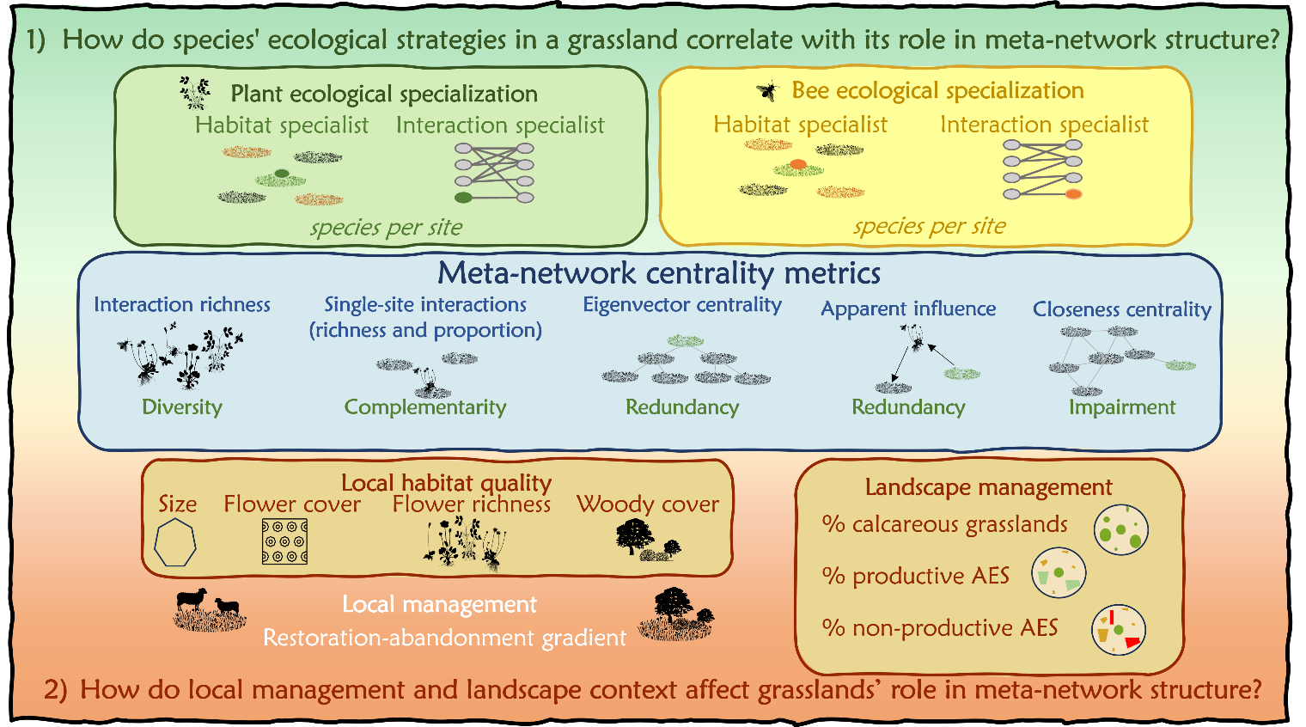

Figure 1: Conceptual summary of the analytical framework. We studied how species ‘ecological specialization (habitat and interaction specialization) is related to meta-network metrics of individual grasslands. Additionally, we analyzed the effect of local habitat quality, created by a gradient of local management, and landscape context, i.e. the cover of calcareous grasslands and AES in the surrounding landscape, on the role of the grasslands in the meta-network structure. Landscape AES were either integrated into crop production (productive AES) or set aside measures (non-productive AES).

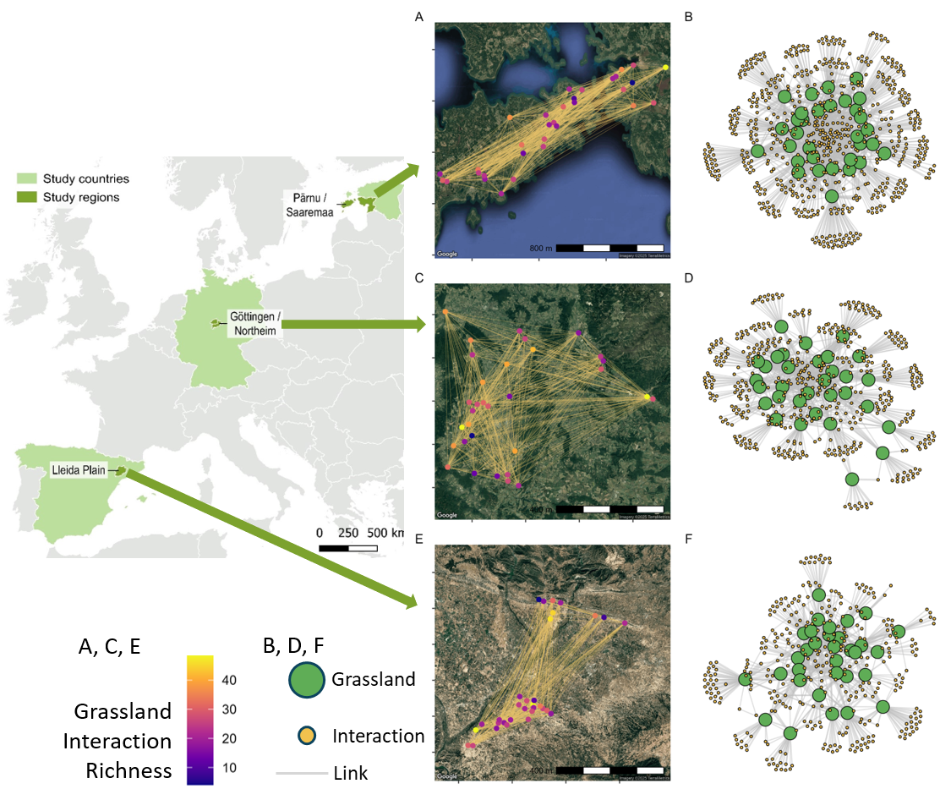
Figure 2: Map of studied regions and representation of each meta-network per country. Studied regions are marked in dark green on the European map. For each country, the representation of the plant-wild bee meta-networks structure is presented using two different projections. 1) Panels A, C and E show the unipartite projection where the location of calcareous grasslands is presented in colored dots based on the number of interactions hold in each grassland, and yellow lines connect calcareous grasslands when they share the same plant-wild pollinator interaction, projected in the physical maps (satellite images from Google Maps, 2025). 2) Panels B, D and F show the bipartite projection: calcareous grasslands are represented by green nodes, whereas interactions are represented by yellow nodes. Whenever an interaction is occurring uniquely in one site during the whole monitoring period (single-site interactions), the yellow node connects with one single green node.

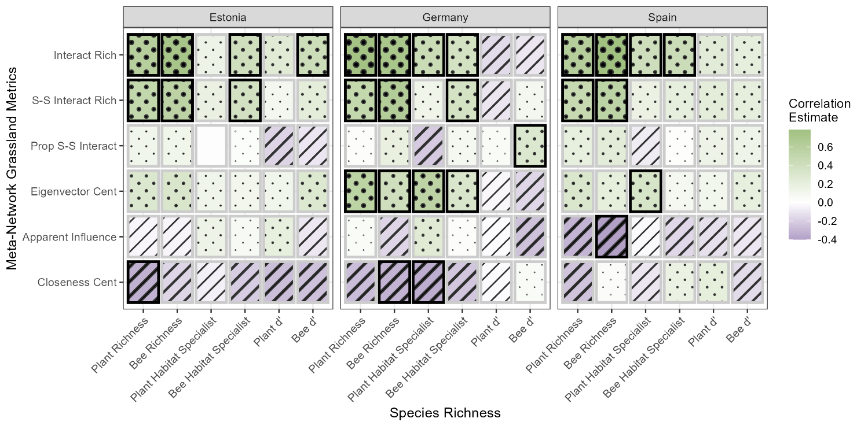
Figure 3: Kendall correlations among grassland meta-network metrics (Interact Rich: richness of interactions; S-S Interact Rich: number of single-site interactions; Prop S-S Interact: proportion of single site interactions, Eigenvector Cent: grasslands eigenvector centrality; Closeness Cent: grasslands closeness centrality; Apparent Influence: grasslands apparent influence) and species’ richness and ecological specialization (GP: Generalist Plant; GB: Generalist Wild Bee; SP: Specialist Plant; SB: Specialist Wild Bee; WP: Widespread Plants; LP: Local Plants). Tile color indicates the correlation estimate (see legend: green for positive, purple for negative), while texture provides redundant encoding: striped tiles represent positive correlations, dotted tiles represent negative correlations, and denser textures indicate stronger associations. Significant results are marked with thick black margin of the tile.

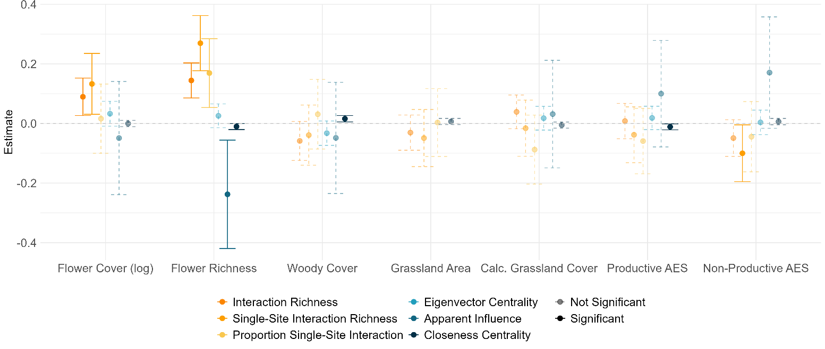
Figure 4: Effect of the flower cover, flower richness, woody cover, grassland size, landscape cover of calcareous grasslands, landscape cover of productive AES, and landscape cover of non-productive AES on the studied meta-network metrics differentiated by color (see legend). Whiskers represent 95% confidence intervals of the estimated effects. An explanatory variable is significant if whiskers do not overlap the zero dashed line (shown in bold). Non-significant effects are show with dashed and transparent lines. Country effects have been dropped for visualization purposes.

